KENDRIYA VIDYALAYA No.2, BOLANGIR

SUMMATIVE ASSESSMENT- I SESSION: 2014-15

SUBJECT: MATHS TIME: 2 Hrs30min.

NAME: _______________________________________________ Roll No.:______

CLASS: III SEC___ DATE: ____-09-2014

Invigilator’s Sign______ Examiner’s Sign. _________

|  |  |  |  |  |  |
| --- | --- | --- | --- | --- | --- |
| COMPETENCIES | KNOWLEDGE | UNDERSTANDING | ABILTY IN  COMPUTING | Problem  Solving Ability | Over all  Grade |
|  |  |  |  |  |  |

# KNOWLEDGE

Which view of the objects is shown below .

Q1.) Q2.)

Q3.

)

O

ne year=_____months

.

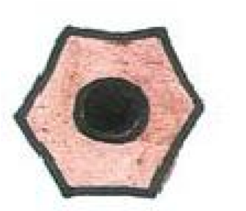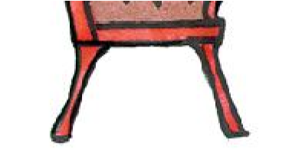

Q4.) One week =__________days.

Q5.) Draw dotted line to divide the picture equally.

Q 6.) Observe the figure and answer the following?

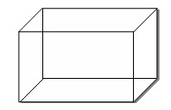

* 1. How many corners does it have ? ______
  2. How many edges does a dice have ? ______

Q7.) Match the following

Date Celebrated as

26th January Gandhi’s Jayanti

15th August Children’s Day

2nd October Republic Day

14th November Independence Day

Q8.)Write the numbers name.

1. 517 = ___________________________________________________
2. 808 = ___________________________________________________

Q9.) Split the number as given. 143= 100+40+3

256=

387=

Q10.) Draw a beautiful weaving patterns and colour it.

UNDERSTANDING

*Fill in the blanks.*

Q11) 10 less than 90 is ______________

Q12) What number is missing from the series?

80 ,75, 70, ______ , 60,55

Q13) Length of a TV can be measured in_________.(Km, m,cm)

Q14) Observe the moon and tick the correct option.

It has Straight edge **/** Curved edge

Q15) Distance from classroom to school gate is 50_____ . (Km, m, cm)

Q16).Make shape for given number . for 100’s for10’s for 1’s

1

345=

123=

Q17) Fill in the blanks

1. A duster has ______corners and _____edge.
2. A sheet of paper has ______corner and _____edge.

Q18)Fill the missing numbers in the given boxes.

|  |  |  |  |  |
| --- | --- | --- | --- | --- |
| **7** | **8** | − |  | **6** |
| **3** |  | **3** |  |
|  | **5** | **6** | **0** |

−

Q19*)* Find these numbers from the given chart . Colour them*.*

|  |  |  |  |  |
| --- | --- | --- | --- | --- |
| 75 | 30 | 43 | 66 | 18 |
| 95 | 89 | 32 | 50 | 17 |
| 81 | 40 | 59 | 21 | 72 |
| 56 | 39 | 200 | 24 | 47 |

____________________________________________________

Green Red Yellow

____________________________________________________

Thirty Fifty six Eighty Nine

20+30 24+23 33+10

1+20 22+10 44+22

Two Hundred Eighteen Forty

____________________________________________________

ABILITY TO COMPUTE

Fill in the blanks

Q20).11 less than 66 is ______ .

Q21).10 and 40 more is ______ .

Q22).The sum of 9 and 44 is _____ .

Q23).Mohit has got 95 mark this time.last time he has got 69 marks. How many . more mark does he got this time

Q24).Spilt the numbers and add.

Ex.

26+43 Q ) 37+ 52

20+6+40+3 = + + +

+

20+40+6+3 = + + +

80+9 =

89 =

Q25) Make question for the following statement.

Ans. Bunty has read 27 books and bubbli has read 34 books.

Q26).Complete the following circles*.*

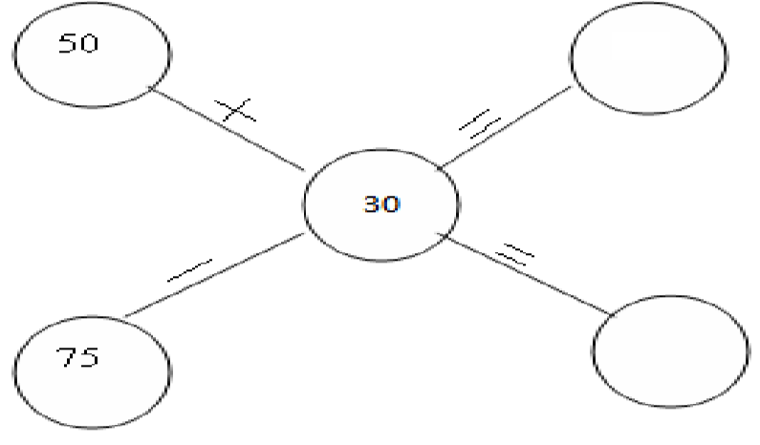

Q27). Fill in the blank

|  |  |  |  |  |
| --- | --- | --- | --- | --- |
| 50 |  | 70 |  | 20 |

a)_____ +________=_________ b) _____ --________=________

c) _____ +________=_________ d) _____ --________=_________

PROBLEM SOLVING ABILITY

Q28). I have 3 corners, 3 sides. Now say who am I ___________.

Fill in the column.

Q29)

353 Q30) 645

+ 245 + 532

Q31). How many triangles are there in the following figure ?

Ans. __________

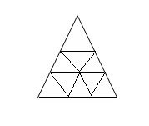

Q32).A factory made 270 bulbs on the first day. On the second day it made 188 bulbs. How many bulbs did the factory made altogether ?

Q33) Daniel had Rs.368/- in his purse he brought a bag for Rs.123/-. How much money left in his purse?

Ans : Daniel had money = Rs ……………

He bought a purse = Rs …………

Money left with him = Rs …… − Rs … . = Rs ……………

Q34 ) Vishesh bought a shirt for Rs.125/- and trousers for Rs.165/-. How much money did he spend altogether?

Ans : Vishesh bought a shirt for Rs ……………

He bought a trousers for Rs ……………

He spent money altogether = Rs …… + Rs ……….= Rs …….

Q35). Observe the table and find the answer of the question given below.

|  |  |
| --- | --- |
| PLAYER | RUN SCORED |
| Sachin | 128 |
| Sehwag | 100 |
| Gambhir | 99 |
| Virat | 162 |
| M.S.dhoni | 152 |

i)___________ scored a complete century. no less, no more.

ii)__________ and _________ have a difference of just 1 run between them.

iii)____________scored the highest run.

iv)__________ missed the century by 1 run.

*SPACE FOR ROUGH WORK*

# KENDRIYA VIDYALAYA No.2, BOLANGIR

SUMMATIVE ASSESSMENT- I SESSION: 2014-15

SUBJECT: MATHS TIME: 2 Hrs

NAME: _____________________________________ Roll No.:____

CLASS: IV SEC___ DATE: __-09-2014

Invigilator’s Sign______ Examiner’s Sign. _________

|  |  |  |  |  |  |
| --- | --- | --- | --- | --- | --- |
| COMPETENCIES | KNOWLEDGE | UNDERSTANDING | ABILTY IN  COMPUTING | Problem  Solving  Ability | OVER  ALL  GRADE |
|  |  |  |  |  |  |

CONCEPT

KNOWLEDGE

1. Answer the following*.*
   1. 1 Litre = _____________ mililitres .
   2. 1 Hour = __________ minutes .
   3. 1 Metre = __________ cm
   4. 16 x8 =__________
   5. One rupee = _________ paise
2. Answer the following.

a) A labour earns Rs 30 in a day .How much money will he earn in 8 days?

Ans : A labour earns in one day = Rs …………

He will earn in 8 days = Rs …………. X ………….= Rs ………….. b) Add the following.

50 metres 35 centimetres

+ 25metres 40 centimetres

_________________________________________

1. Ayushman had 1 litre water. His friend Sahil drank 200 ml. water fromAyushman.

Now how much water left with Ayushman ?

Ans : Ayushman had water = ……………….. l.

Sahil drank = …………………. ml.

1 Litre=………..ml.

Water left with Ayushman = ………… ml -- ………..ml = ……………ml.

1. 60 children of class IV are going for a picnic . On the way , each of them is given 5

biscuits. Now find out how many biscuits are distributed among 60 children ?

Ans : Each child is given = ………….. biscuits

60 Children are given = ……………. X …………. = …………Biscuits

1. The cost of 1 brick is 5 rupees . Then How much will you pay for 100 bricks ?

Ans : Cost of 1 brick = Rs ………..

Cost of 100 bricks = Rs ……….. X ……….. = Rs ………………

## UNDERSTANDING

1. Answer the following.
   1. Write 20 : 30 hours in 12 hours format using AM or PM. _____________
   2. Write the name of month here. 20-10 –2009 ______________
   3. How many faces does a brick have ? ____________
   4. 60cm + __ cm = 1 Metres
   5. How many hands are there in a clock ? _______________
2. Answer the following.
   1. Draw a Brick pattern.

* 1. Draw the top view of a railway track .

* 1. Draw the side view of a shoe .

1. Following are given some dates . Arrange them in a calendar order .

16 February 2010 , 19 December 2010, 15 August 2010 , 25 November 2010

a)__________________________

b)___________________________

c)___________________________

d)___________________________

ABILITY TO COMPUTE

1. Answer the following.
   * 1. 2 X 3 X 6 =___________
     2. 20 litres milk + 10 litres milk = ____________ litres milk
     3. 30 metres – 10 metres = ______________ metres 7) Answer the following.

a) One bus can carry 48 children. How many children can three buses carry ?

Ans : One bus can carry = ………………. Children.

3 buses can carry = ……………. X ………. = ……………… children

* 1. A fruit seller bought 1 dozen of bananas for 25 rupees and sold them for 30 rupees . Then how much did he earn ?

Ans : He bought 1 dozen banana = Rs …………..

He sold 1 dozen banana = Rs …………….

He earned = Rs ……….. -- Rs …………. = Rs ………………..

* 1. The age of an elephant is 95 year old and the age of a rat is 2 year old . How much older is the elephant than the rat ?

Ans : Age of the elephant = ……………years

Age of the ant = ……………….years

The elephant is older than the rat = ………. Years --- ………years = ……years

* 1. The price of 1 litre petrol is 60 rupees . Then how many rupees do you pay for 9 litres of petrol ?

Ans : Price of 1 ltr petrol = Rs ………

Price of 9 ltrs petrol = Rs ……… X ………….. = R s ………………

1. Find out the answer from the table.

|  |  |
| --- | --- |
| Raja’s Rate List | |
| Kind of junk | Price of 1 kg |
| News paper | Rs. 5 |
| Iron | Rs10 |
| Brass | Rs 50 |
| Plasticks | Rs 8 |

* 1. How much money will you pay for 20 kg of newspaper ?

_____________________________________

* 1. What is the cost of 2Kg Iron ?

_____________________________________ iii) What is the cost of 4Kg Brass ?

_____________________________________ iv) What is the cost of 8Kg plastics ?

_____________________________________

P.S.A.

1. Fill in the blanks .
   1. One Lakh = ___________Hundreds .
   2. In a 4000 metre race people run _____________ kms.
   3. 200 ml = 100 ml + _________ ml .
2. Answer the following .
3. Cost of 1000 bricks is Rs 1600 . What is the cost of 2000 bricks ?

Ans : Cost of 1000 bricks = Rs ………

Cost of 2000 bricks = Rs …………….. X ………………… = Rs ………………

1. What is the boundary of the field ? 50 m

Ans : 50 m 50 m

50 m

1. Think of a number which can be divided by 2, 3 and 5 and it comes between 25 and 35 ?

Ans :_________________________________________________

1. Chinmayee buys 1Kg. iron for Rs. 12 . But she sells it for Rs 14 . How much does she earn when she sells 20 k. g. iron ?

Ans : In 1 kg iron She earns = Rs …………. -- Rs …………….. = Rs ……………..

In 20 kg iron She earns = Rs …………. X …………. = Rs ……………

11) Two friends guess the time and wrote below . Tick on correct answer

**Peelu’s Answer Neelu’s Answer**

|  |  |  |
| --- | --- | --- |
|  | 12:15 | 3:00 |
|  | 4:30 | 5:30 |
|  | 10:55 | 11:00 |
|  | 7:35 | 8:35 |

|  |
| --- |
|  |

## KENDRIYA VIDYALAYA NO.2 BOLANGIR

SUMMATIVE ASSESSMENT-1 (SA-I) SESSION: 2014-15

SUBJECT: MATHEMATICS CLASS :V SEC: __________ TIME:2.30 HOURS

NAME: ______________________________ ROLL NO. ____ DATE :______________ SIGN.OF INVIGILATOR____________ SIGN OF EXAMINER ___________________

|  |  |  |  |  |  |
| --- | --- | --- | --- | --- | --- |
| COMPETENCIE  S | KNOWLEDGE | UNDERSTANDIN  G | ABILTY  IN  COMPUTING | PROBLEM  SOLVING  ABILITY | OVER  ALL  GRADE |
| GRADE |  |  |  |  |  |

### KNOWLEDGE

Q. Fill in the blank space.

1. A right angle = ___________ degrees.
2. How many sides are there in a hexagon figure? ___________________
3. Write the place value of ‘2’ in 251543. ___________________
4. How many20 paise will make 1 rupee? ___________________ (5) How many grams are equal to 1 kilogram ? ___________________ Q. Solve the following problems.
5. Write any four multiples of 6.

Ans___________________________________________________

1. Find out the area of the following shaded shapes. (1 square box= 1 square cm)

Ans: ____________________ square cm.

8) Draw an angle of 45 degree. Ans:

1. What is the area of this square?

|  |
| --- |
|  |

5cm

Ans:_________________________________

1. Colour యర part of the given circle . Ans:-

### UNDERSTANDING

Q. Fill in the blanks.

1. The length of the boundary is also called _________________________.

(Area/ Perimeter)

1. Write the half turn of H. _________________
2. Write the భర turn of 6. _________________
3. Colour the యర of this figure. _________________

|  |  |  |
| --- | --- | --- |
|  |  |  |
|  |  |  |

1. Write the names of English alphabet which will be the same

after భమturn.

…………………………………………………………………………………………………

Q.Answer the following questions.

1. Find out any two common multiples of 6 and 9. Ans

…………………………………………………………………………………………………………………

…………………………………………………………………………………………… ………………………………………………………………………………………………………

1. Find out the common factors of 18 and 24.

Ans:-

………………………………………………………………………………………………………………… …………………………………………………………………………………………………………………

………………………………………………………………………………… (18) A motor boat travels

25kms in 1 hour. How long it travel in 4hours ? …………………………………………………………………………………………………………………

…………………………………………………………………………………………………………………

………………………………………………………………………………………………………………… …………………………………………………………………………………………………………………

……………………………………………………………19) What kind of angle ( acute, obtuse ,right) is made by the hands of these clocks. Also write the time.



I) Angle ------------------ II) Angle ------------------

I) Time ------------------ II) Time ------------------

### ABILITY TO COMPUTE

Q. Write the number names of the following numbers. (VSA)

1. 2484061=……………………………………………………………………………………
2. 8759450=……………………………………………………………………………………

1. One million = --------------Lakhs

Q. Answer the following.

23) Write two equivalent fraction of లళ.

Ans:-

…………………………………………………………………………………………………………………

…………………………………………………………………………………………………………………

…………………………………………………………………………………24)Write the factors of 25 in the circle ‘A’ and the factors of 35 in the circle ‘B’.

Write the common factors in the coloured space.

A B

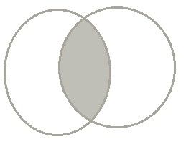

Q. Write the mirror image of the following.

1. FIXING = _____________________________
2. MATHS = ____________________________
3. Match the following.

A B

|  |  |  |
| --- | --- | --- |
| Proper fraction |  | భభవ , భఱభయ , మబభళ |
| Unit fractions |  | ళ , భ , మ |

|  |  |
| --- | --- |
|  | ఴ ఴ ఴ |
| Improper fraction | భయ , భర , భఱ |
| Like fractions | భ , మ , భభ |

య ఱ భయ

PROBLEM SOLVING ABILITY Q. Answer the following questions.

1. How many భర will make a whole?

Ans………………………………………………………………………………………………………………

……………………………………………………………………………………………29) Multiply: మఴ x

1భఱ

………………………………………………………………………………………………………………… …………………………………………………………………………………………………………………

…………………………………………………………………………………

30) Arrange in ascending order . ళఴ , భఴ , మఴ

Ans…………………………………………………………………………………………………

………………………………………………………………………………………………………

Q. See the data given and give answer of the questions that follows:-

Name of the Items Price in Rs. Per Kg

Tomato 15

Potato 12

Onion 16

Carrot 20

Gourd 12

1. How much does 2 Kg of tomato cost?

………………………………………………………………………………………………………

………………………………………………………………………………………………………

1. How much does భమKg of potato cost ?

…………………………………………………………………………………………………………………

……………………………………………………………………………………………

1. What is the cost of 1 భమ Kg of onion? …………………………………………………………………………………………………………………

……………………………………………………………………………………………

1. What is the cost of యర Kg of Gourd?

…………………………………………………………………………………………………………………

……………………………………………………………………………………………

35) Draw the factor tree of the following numbers.

1. 24
2. 45